In Class Assessment 2 - Blazor Pages Web Application
Overview
In this asseessment you will alter an ASP.NET Core Web App using Blazor Pages to collect tour data and display the collected data.
A starter kit has been supplied for you. You must code your answer in the supplied solution. It contains:
- A folder called Data to hold the csv text files. One file is for good data, one file is empty, and the last file holds a mixture of good and bad data for testing your code.
- A folder called Model with a class called Excursion and an enum called ExcursionType. Excursion has a .ToString() method that will produce the record layout for the csv text file. It also contains a static method to parse a csv record into an instance of Excursion. Do Not modify this class.
You will modify 2 existing Blazor Pages:
- ExcursionCollection will collect data and append the data to a csv text file.
- ExcursionSchedule will read a csv text file and display the data within in a tabular view.
Use Frequent Commits
Commit your work at the end of each and every Activity. Make it clear which activity a commit is for in the commit message.
Mark(s) may be deducted based on the commit activity in your repository.
Ensure you sync your local clone to GitHub before the end of class. The classroom assessment ends at the end of class period.
It is your responsibility to ensure your work is coded in the supplied solution and properly submitted. It is your repsonsibiltiy to ensure your work is properly submitted. Failure to submit your work as requested may result in deductions up to and including a final mark of 0 (zero) for this assessment.
Requirements
Activity 1
Home.razor
Modify the existing h4 heading in the Home.razor file with your full name.
Activity 2
ExcursionSchedule Tabular Report component
Modify the Blazor Page named ExcursionSchedule.razor. Write code to:
- Display the data of a csv text file in a tabular display.
- Read a csv text file filled with tour excursion data.
An area to display a summary of errors has already been placed on the page.
Examples
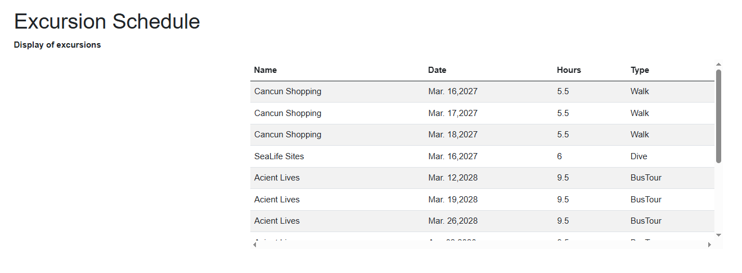

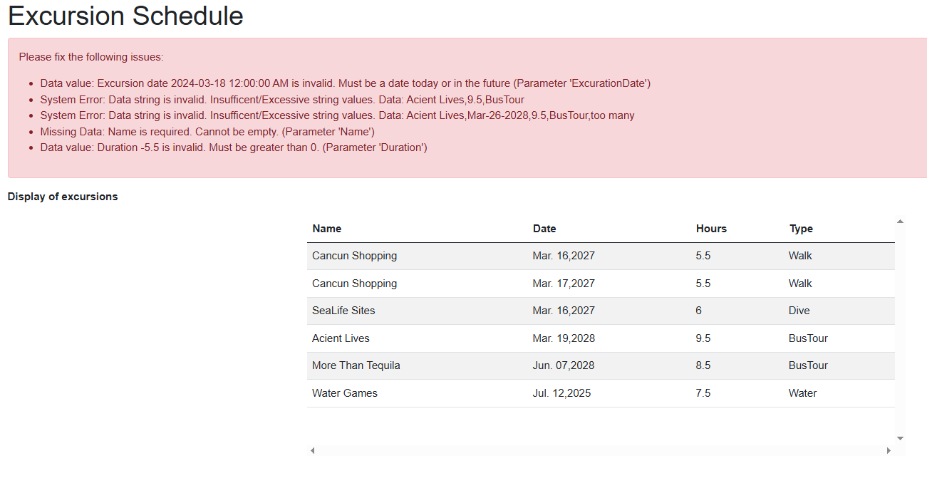

> 1. Display all fields of the Excursion instance.
> 2. Display an unique message if:
> - the csv text file is not present
> - the csv text file is empty.
> 3. Process **all** records in the file.
> 4. Display a message if the csv text record has a format or other thrown error.

## Activity 3
### ExcursionCollection component

Modify the Blazor component named `ExcursionCollection.razor`. Write the code to:

1. Create the mockup form image shown below. **Do not** use `EditForm`.
2. Validate all data. This should be done in the event method.
3. Add any necessary properties/variables to the page for your form.
4. Collect and display **all** possible errors at one time. An area to display a summary of errors has already been placed on the page.
5. Append the data to the good csv file located in the `Data` folder if the data passes validation.

### Example

**The page does not need to match the given layout BUT all controls must be present.**

